Ahmed Chowdhury

Assignment 5

CSC 3750

Code for index:

<!DOCTYPE html>

<html lang="en">

<head>

<meta charset="UTF-8">

<meta http-equiv="X-UA-Compatible" content="IE=edge">

<meta name="viewport" content="width=device-width, initial-scale=1.0">

<title>Document</title>

</head>

<link rel="stylesheet" href="KhaiKhai.css">

<script src="https://kit.fontawesome.com/6f0e8eb73f.js" crossorigin="anonymous"></script>

</head>

<body>

<header>

<nav>

<div class="logo">Khai Khai</div>

<input type="checkbox" id="fo">

<label for="fo" class="bal"><i class="fas fa-bars"></i></label>

<ul>

<li><a href="index.html">Home</a></li>

<li><a href="Menu.html" target="_blank">Menu</a></li>

<li><a href= "Catering.html" target="_blank">Catering</a> </li>

<li><a href="OnlineOrders.html" target="_blank">Online Orders</a></li>

<li><a href="">Review</a></li>

</ul>

</nav>

</header>

<img src="Restaurant-01.png" alt="">

<!--Icon image -->

<video controls autoplay>

<source src="video.mp4" type="video/mp4">

</video>

<h1><br>PRIDE OF BANGLADESH</h1>

<h3>The Restaurent </h3>

<p>KHAI KHAI is an Indian BANGLADESHI restaurant which offers a variety of indian dishes and also indo thai special. </p>

<h3>Catering</h3>

<p>We cater small parties as well as big parties of up to 500 peoples.</p>

<h3>Location and Hours</h3>

<p>Warren MI <br>4722 ANNA ST, WARREN, MI 48092 <br> </p>

<table>

<!--Table for the hours-->

<tr>

<td>Days</td>

<td>Hours</td>

</tr>

<tr>

<td>Monday</td>

<td>10am-11pm</td>

</tr>

<tr>

<td>Tuesday</td>

<td>11am-11pm</td>

<tr>

<td>Wednesday</td>

<td>10am-11pm</td>

</tr>

<td>Thursday</td>

<td>9am-10pm</td>

</tr>

<tr>

<td>Friday</td>

<td>10am-12pm</td>

</tr>

<tr>

<td>Saturday</td>

<td>12pm-1am</td>

</tr>

<tr>

<td>Sunday</td>

<td>12pm-10pm</td>

</tr>

</table>

<footer> <a href="https://www.instagram.com/Khai Khai/?hl=en" target="_blank"><i

class="fa-brands fa-square-instagram"></i></a>

<a href="https://www.facebook.com/Khai Khai/" target="_blank"><i

class="fa-brands fa-square-facebook"></i></a>

<a href=""><i class="fa-brands fa-square-twitter"></i></a>

<a href=""><i class="fa-brands fa-linkedin"></i></a>

</div>

<p><small>Copyright &copy; Ahmed C.</small></p>

</footer>

</body>

</html>

Code for Menu:

<!DOCTYPE html>

<html lang="en">

<head>

<meta charset="UTF-8">

<meta http-equiv="X-UA-Compatible" content="IE=edge">

<meta name="viewport" content="width=device-width, initial-scale=1.0">

<title>Document</title>

</head>

<link rel="stylesheet" href="KhaiKhai.css">

<script src="https://kit.fontawesome.com/6f0e8eb73f.js" crossorigin="anonymous"></script>

</head>

<body>

<header>

<nav>

<div class="logo">Khai Khai</div>

<input type="checkbox" id="fo">

<label for="fo" class="bal"><i class="fas fa-bars"></i></label>

<ul>

<li><a href="index.html">Home</a></li>

<li><a href="Menu.html" target="_blank">Menu</a></li>

<li><a href= "Catering.html" target="_blank">Catering</a> </li>

<li><a href="OnlineOrders.html" target="_blank">Online Orders</a></li>

<li><a href="">Review</a></li>

</ul>

</nav>

</header>

<article>

<div class="main">

<h4><br><br><br><br>Khai Khai Menu</h4>

</div>

<p5 class="Dinner">Featuring "Awesome Indian cuisine.<br>This menu is made by the

authentic Mughal and

flavors of <em>Indian subcontinent</em> It also has influence of Bangladeshi and Indo Chinese food.</p5>

</article>

<div class="fc">

<div class="fb1">

<h5>Samosa</h5>

<div>

<p>

Mouth watering Choice of beef or chicken.Served with the choice of green or red sauce.</p>

<br>

<img src="samosa.jpeg" alt="" class="imgc">

<br>

</div>

<div class="price">

<p4>$2.99</p4>

</div>

</div>

<div class="fb1">

<h5>Samosa</h5>

<div>

<p>

Chicken Biryani is a savory chicken and rice dish that includes layers of chicken, rice, and aromatics that are steamed together.</p>

<br>

<img src="cb.jpeg" alt="" class="imgc">

<br>

</div>

<div class="price">

<p4>$2.99</p4>

</div>

</div>

<div class="fb1">

<h5>Samosa</h5>

<div>

<p>

It is a type of curry made from chicken with a spiced tomato and butter (makhan) sauce. Its sauce is known for its rich texture. </p>

<br>

<img src="bc.jpeg" alt="" class="imgc">

<br>

</div>

<div class="price">

<p4>$2.99</p4>

</div>

</div>

<div class="fb1">

<h5>Samosa</h5>

<div>

<p>

Mouth watering Choice of beef or chicken.Served with the choice of green or red sauce.</p>

<br>

<img src="samosa.jpeg" alt="" class="imgc">

<br>

</div>

<div class="price">

<p4>$2.99</p4>

</div>

</div>

<div class="fb1">

<h5>Samosa</h5>

<div>

<p>

Mouth watering Choice of beef or chicken.Served with the choice of green or red sauce.</p>

<br>

<img src="samosa.jpeg" alt="" class="imgc">

<br>

</div>

<div class="price">

<p4>$2.99</p4>

</div>

</div>

<div class="fb1">

<h5>Samosa</h5>

<div>

<p>

Mouth watering Choice of beef or chicken.Served with the choice of green or red sauce.</p>

<br>

<img src="samosa.jpeg" alt="" class="imgc">

<br>

</div>

<div class="price">

<p4>$2.99</p4>

</div>

</div>

<div class="fb1">

<h5>Samosa</h5>

<div>

<p>

Mouth watering Choice of beef or chicken.Served with the choice of green or red sauce.</p>

<br>

<img src="samosa.jpeg" alt="" class="imgc">

<br>

</div>

<div class="price">

<p4>$2.99</p4>

</div>

</div>

<div class="fb1">

<h5>Samosa</h5>

<div>

<p>

Mouth watering Choice of beef or chicken.Served with the choice of green or red sauce.</p>

<br>

<img src="samosa.jpeg" alt="" class="imgc">

<br>

</div>

<div class="price">

<p4>$2.99</p4>

</div>

</div>

</div>

<footer> <a href="https://www.instagram.com/Khai Khai/?hl=en" target="_blank"><i

class="fa-brands fa-square-instagram"></i></a>

<a href="https://www.facebook.com/Khai Khai/" target="_blank"><i

class="fa-brands fa-square-facebook"></i></a>

<a href=""><i class="fa-brands fa-square-twitter"></i></a>

<a href=""><i class="fa-brands fa-linkedin"></i></a>

</div>

<p><small>Copyright &copy; Ahmed C.</small></p>

</footer>

</body>

</html>

Code for online order:

<!DOCTYPE html>

<html lang="en">

<head>

<meta charset="UTF-8">

<meta http-equiv="X-UA-Compatible" content="IE=edge">

<meta name="viewport" content="width=device-width, initial-scale=1.0">

<title>Document</title>

</head>

<link rel="stylesheet" href="KhaiKhai.css">

<script src="https://kit.fontawesome.com/6f0e8eb73f.js" crossorigin="anonymous"></script>

</head>

<body>

<header>

<nav>

<div class="logo">Khai Khai</div>

<input type="checkbox" id="fo">

<label for="fo" class="bal"><i class="fas fa-bars"></i></label>

<ul>

<li><a href="index.html">Home</a></li>

<li><a href="Menu.html" target="_blank">Menu</a></li>

<li><a href= "Catering.html" target="_blank">Catering</a> </li>

<li><a href="OnlineOrders.html" target="_blank">Online Orders</a></li>

<li><a href="">Review</a></li>

</ul>

</nav>

</header>

<form>

<div class="fname">

<label for="fname"> First name:</label>

<input type = "text" id ="fname">

<br>

</div>

<div class="fname">

<label for="lname"> Last name:</label>

<input type = "text" id ="lname">

</div>

<br>

<div class="fname">

<label for="email">email:</label>

<input type="email" id="email" required>

</div>

<br>

<div class="fname">

<label for="phone">phone #:</label>

<input type="tel" id="phone" required>

</div>

<h2>Please select items from below</h2>

<form>

<div class="fname">

<h2>Breakfast</h2>

<label for="cd">Chana Dosa $9 </label>

<input type="checkbox" id="cd">

<br>

<label for="ch">Chai $5 </label>

<input type="checkbox" id="ch">

<br>

<label for="Ap">Aloo paratha $7 </label>

<input type="checkbox" id="Ap">

<br>

<label for="Dg">Daal Ghosst $7 </label>

<input type="checkbox" id="Dg">

</div>

<div class="fname">

<br>

<h2>Dinner</h2>

<br>

<label for="CB">Chicken Biryani $10 </label>

<input type="checkbox" id="CB">

<br>

<label for="GB">Goat Biryani $13 </label>

<input type="checkbox" id="GB">

<br>

<label for="BB">Beef Biryani $12</label>

<input type="checkbox" id="BB">

<br>

<label for="CT">Chicken Tikka $15</label>

<input type="checkbox" id="CT">

<label for="C65">Chicken65 $12</label>

<input type="checkbox" id="C65">

<label for="BC">Butter Chicken $16</label>

<input type="checkbox" id="BC">

<br>

</div>

<br>

<h2>Spice Level</h2>

<div class="fname">

<label>Very Spicy</label>

<input type="radio" name="n" required>

<label>Medium Spicy</label>

<input type="radio" name="n" required>

<label>Mild Spicy</label>

<input type="radio" name="n" required>

</div>

<br>

<div class="fname">

<label for="payment">payment:</label>

<select id="payment" name="payment">

<option value="visa">visa</option>

<option value="mastercard">mastercard</option>

<option value="giftcard">giftcard</option>

</select>

</div>

<br>

<div class="fname">

<input type="submit">

</div>

<div class="fname">

<input type="reset">

</div>

</form>

</body>

</html>

Code for Css:

*{

margin: 0;

padding: 0;

box-sizing: border-box;

font-family:'Poppins',sans-serif;

}

nav{

width: 100%;

background: red;

display: flex;

flex-wrap:wrap ;

align-items: center;

justify-content: space-between;

}

nav ul {

flex-wrap: wrap;

display: flex;

list-style: none;

}

nav.logo{

font-size: 33px;

color:#fff;

font-weight:600;

}

nav ul li {

list-style: none;

margin: 0 5px;

padding: 0 10px;

border-radius: 10% / 50%;

}

img {

display: block;

margin-left: auto;

margin-right: auto;

height: 150px;

width: 150px;

}

nav ul li a {

text-decoration: none;

color: rgb(193, 15, 15);

font-size: 20px;

border-radius: 5px;

font-weight: 500;

letter-spacing: 1px;

background: #fff;

padding: 8px,10px;

transition: all 0.3s;

}

nav>ul>li:hover {

background-color: #fff;

color: #1b1b1b;

}

nav>ul>li:hover>ul {

display: block;

position: absolute;

}

footer {

font-family: sans-serif;

text-align: center;

margin-top: 50px;

}

body {

background-color: beige (114, 92, 125);

font-family: sans-serif;

margin: 100px 10%;

background-image: url("output-onlinepngtools.png");

background-size: 20px 20px ;

}

h1 {

font-size: 20px;

text-align: center;

color: rgb(228, 6, 6);

font-family: sans-serif;

}

h3 {

color: rgb(233, 16, 16);

}

img {

display: block;

margin-left: auto;

margin-right: auto;

height: 150px;

width: 150px;

}

p{

color: rgb(244, 11, 11);

}

table {

color: rgb(243, 10, 10);

width: 100%;

font-family: sans-serif;

border-radius: 30px ;

}

td,th{

color: black;

}

textarea {

width: 100%;

height: 150px;

padding: 12px 20px;

box-sizing: border-box;

border: 2px solid #ccc;

border-radius: 4px;

background-color: #f8f8f8;

resize: none;

}

input[type=text] {

transition: width 0.4s ease-in-out;

}

input[type=text]:focus {

width: 100%;

}

input[type=button], input[type=submit], input[type=reset] {

background-color: #04AA6D;

border: none;

color: white;

padding: 16px 32px;

text-decoration: none;

margin: 4px 2px;

cursor: pointer;

}

form{

background-image: url('Khail.jpeg');

width:600px;

padding: 200px;

background-size: cover;

}

.fname{

color: white;

filter: drop-shadow(2px 0px 2px #000000);

box-sizing: border-box;

}

h2{

color: white;

}

video{

width: 100%;

border: 2px solid black;

border-top-right-radius: 30px;

border-bottom-left-radius: 30px;

box-shadow: 10px 10px 15px black;

}

img.flo{

float:left;

width:200px;

height:150px;

margin-right: 10px;

margin-bottom: 5px;

-webkit-shape-outside: url(butter.jpeg);

shape-outside: url(butter.jpeg);

}

img.flo{

float:left;

width:200px;

height:150px;

margin-right: 10px;

margin-bottom: 5px;

-webkit-shape-outside: url(fulltray.jpeg);

shape-outside: url(fulltray.jpeg);

}

*{

box-sizing: border-box;

text-align: center;

}

.fc{

display: flex;

flex-wrap: wrap;

flex-direction: row;

width: 100%;

}

.fb1{

width: 300px ;

height: 450px;

margin: 10px;

position: relative;

border: 2px solid black;

box-shadow: 10px 10px 15px black;

}

.price{

width: 100px;

height:30px;

border:1px solid black;

background-color: bisque;

margin-top: auto;

align-items: center;

}

h5{

font-size: 15px;

text-align: center;

color: yellow;

filter: drop-shadow(2px 0px 2px #000000);

font-family: sans-serif;

}

p4{

text-align: center;

color: black;

filter: drop-shadow(2px 0px 2px #000000);

}

imgc{

display: flex;

margin-left: auto;

margin-right: auto;

width: 50%;

}

.fc2{

display: flex;

}

.main{

border: 1px brown;

}

h4{

font-size: 30px;

text-align: center;

color: orange;

font-family: sans-serif;

stroke: #000000;

filter: drop-shadow(2px 0px 2px #000000);

}

p5{

font-size: 20px;

text-align: justify;

font-family: sans-serif;

color: orange;

filter: drop-shadow(2px 0px 2px #000000);

}

nav .bal i{

display: none;

}

#fo{

display: none;

}

@media(max-width: 800px) {

nav ul{

position: fixed;

background:#e0dbdb;

background-image: url("output-onlinepngtools.png");

background-size: 20px 20px;

display: block;

height: 100vh;

width:100%;

left:-100%;

text-align: center;

top:80px;

}

nav .bal i{

color: #FFFFFF;

display: block;

}

nav .bal{

display: block;

}

#fo:checked~ul{

left:0;

}

}

Code for catering:

<!DOCTYPE html>

<html lang="en">

<head>

<meta charset="UTF-8">

<meta http-equiv="X-UA-Compatible" content="IE=edge">

<meta name="viewport" content="width=device-width, initial-scale=1.0">

<title>Document</title>

</head>

<link rel="stylesheet" href="KhaiKhai.css">

<script src="https://kit.fontawesome.com/6f0e8eb73f.js" crossorigin="anonymous"></script>

</head>

<body>

<header>

<nav>

<div class="logo">Khai Khai</div>

<input type="checkbox" id="fo">

<label for="fo" class="bal"><i class="fas fa-bars"></i></label>

<ul>

<li><a href="index.html">Home</a></li>

<li><a href="Menu.html" target="_blank">Menu</a></li>

<li><a href= "Catering.html" target="_blank">Catering</a> </li>

<li><a href="OnlineOrders.html" target="_blank">Online Orders</a></li>

<li><a href="">Review</a></li>

</ul>

</nav>

</header>

<nav>

<ul>

<li><a href="index.html">Home</a></li>

<li><a href="Menu.html" target="_blank">Menu</a></li>

<li><a href= "Catering.html" target="_blank">Catering</a> </li>

<li><a href="OnlineOrders.html" target="_blank">Online Orders</a></li>

<li><a href="">Review</a></a></li>

</ul>

</nav>

<body>

<p>

<br>

<br>

<img src="full tray.jpeg" class="flo" alt="">

Full tray Biryani is perfect for 10 people.Flavored with rich Indian spkices.

Are you and your family craving for biryani order a full tray for $75.99 only.

</p>

<br>

<br>

<p>

<br>

<br>

<br>

<br>

<br>

<img src="butter.jpeg" class="flo" alt="">

Butter chicken is a mild, sweet dish that pairs perfectly with Basmati rice or naan bread.

A meal might include tandoori chicken, mild curry and basmati rice, and steamed vegetables.

Butter chicken origin is North India, in which country it's commonly served as an entrée over white or brown Basmati rice, but not naan.

</p>

</body>

Screenshot of Homepage:

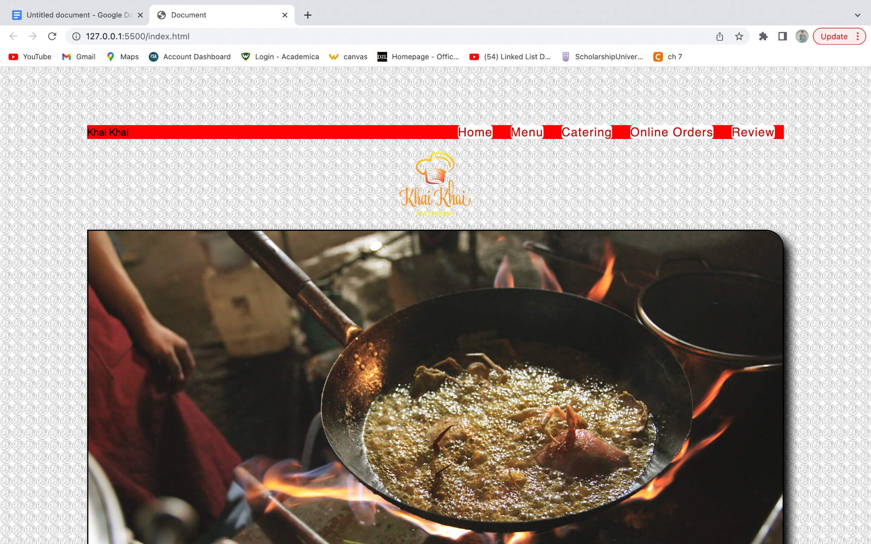

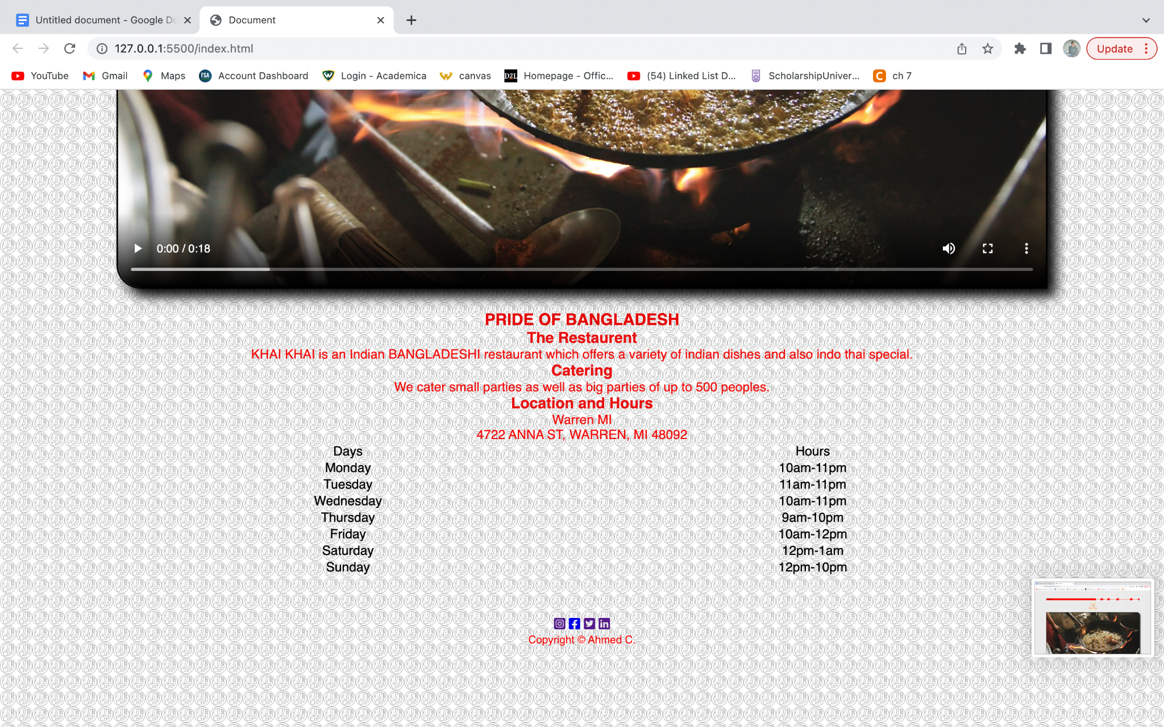

Screenshot of responsive nav:

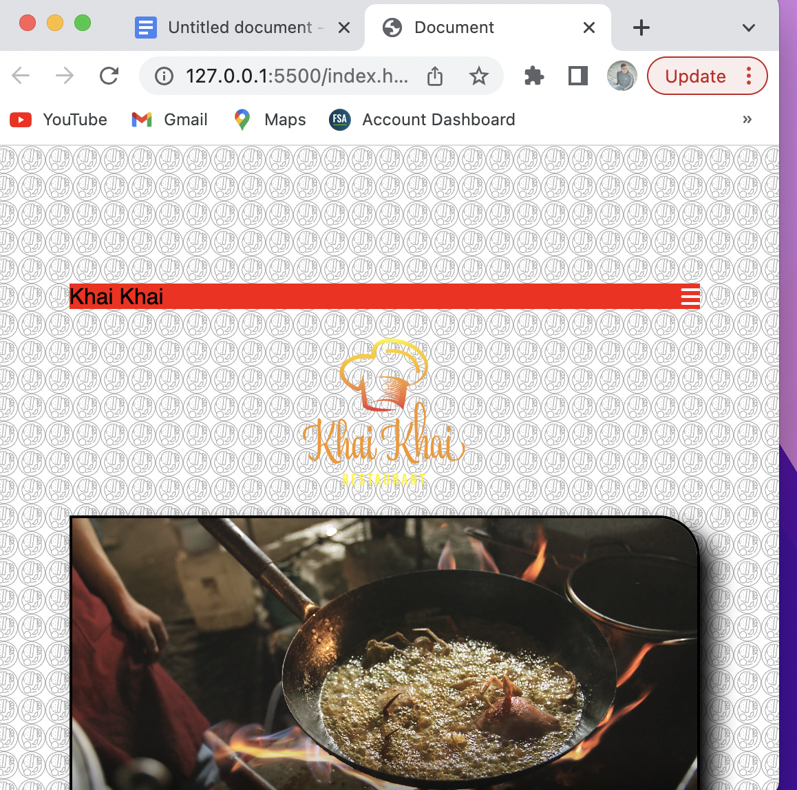

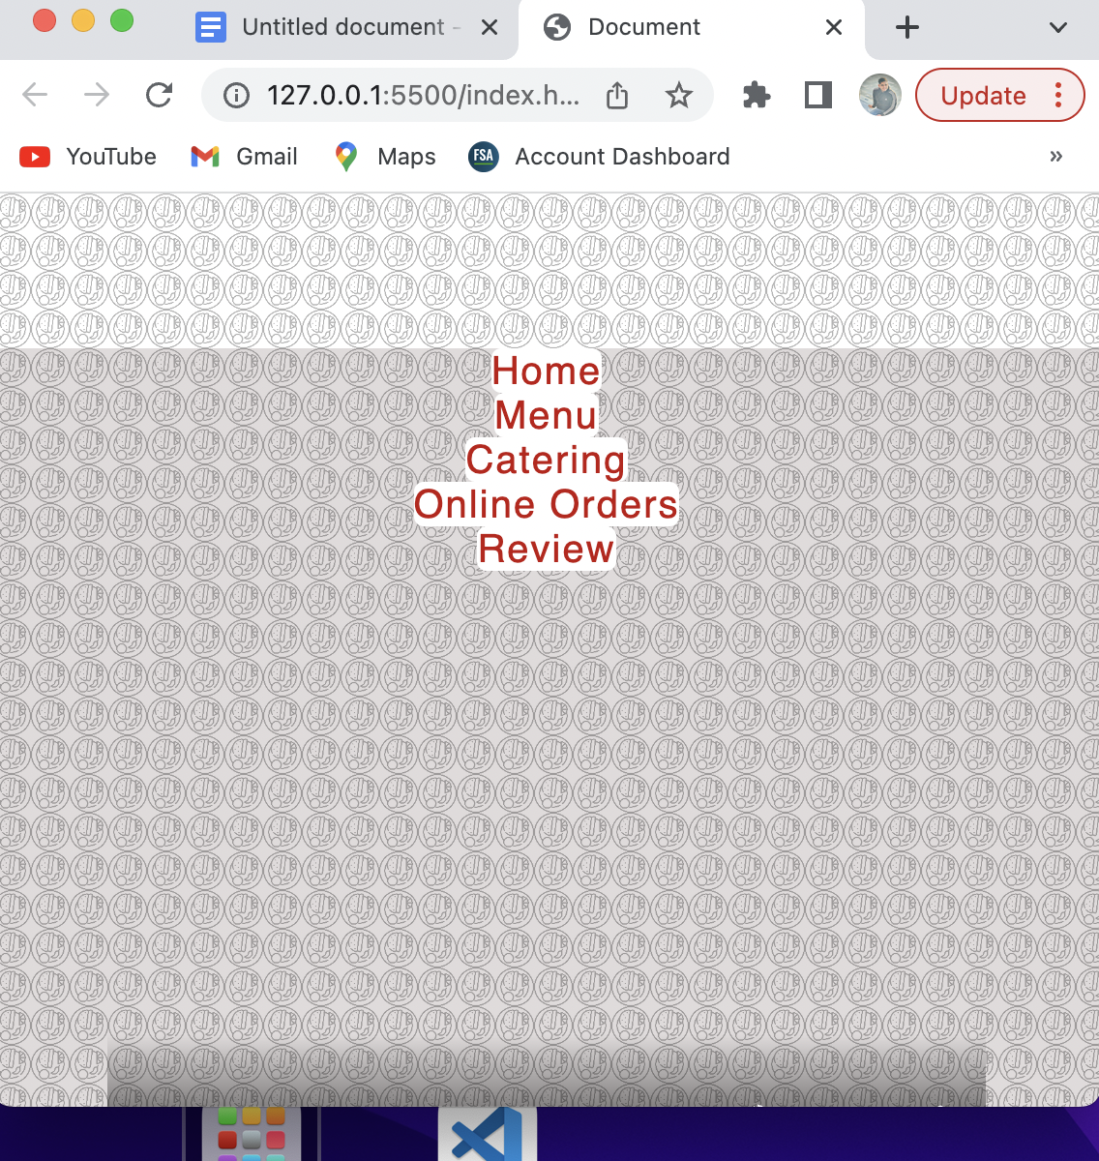

Screenshot of menu with Flexbox:

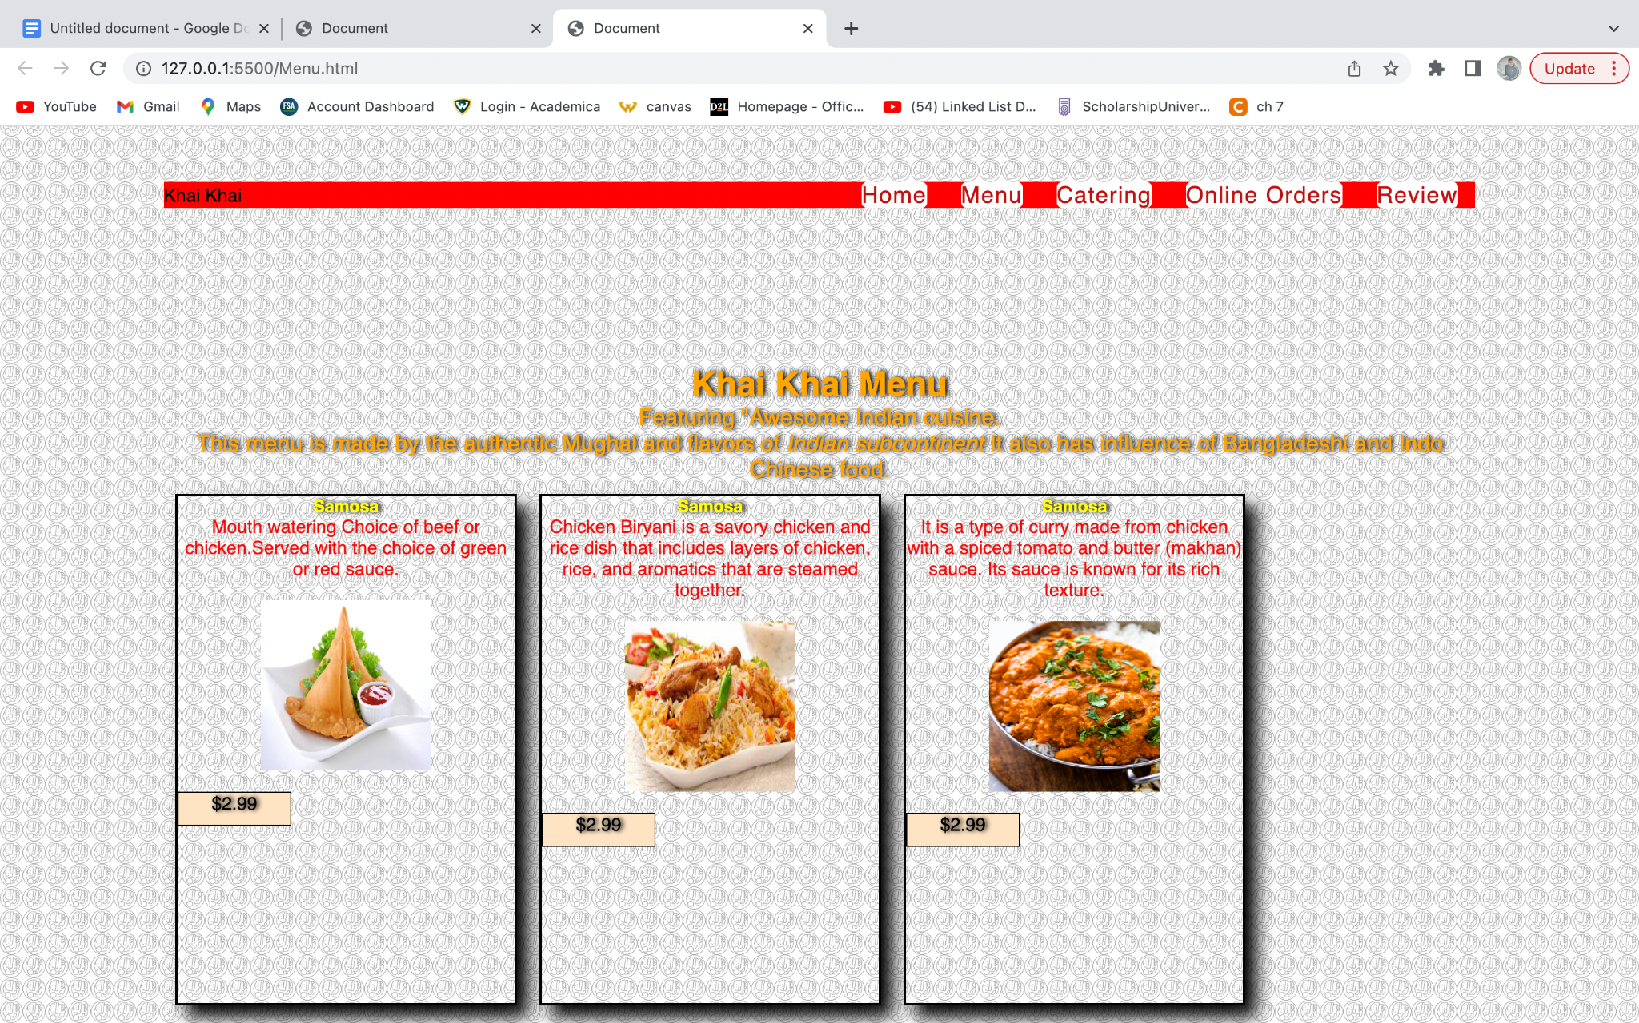

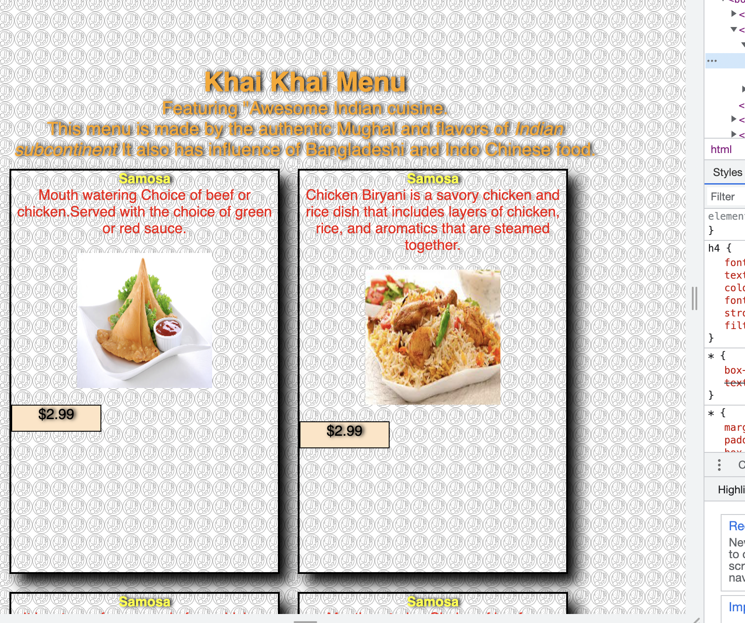

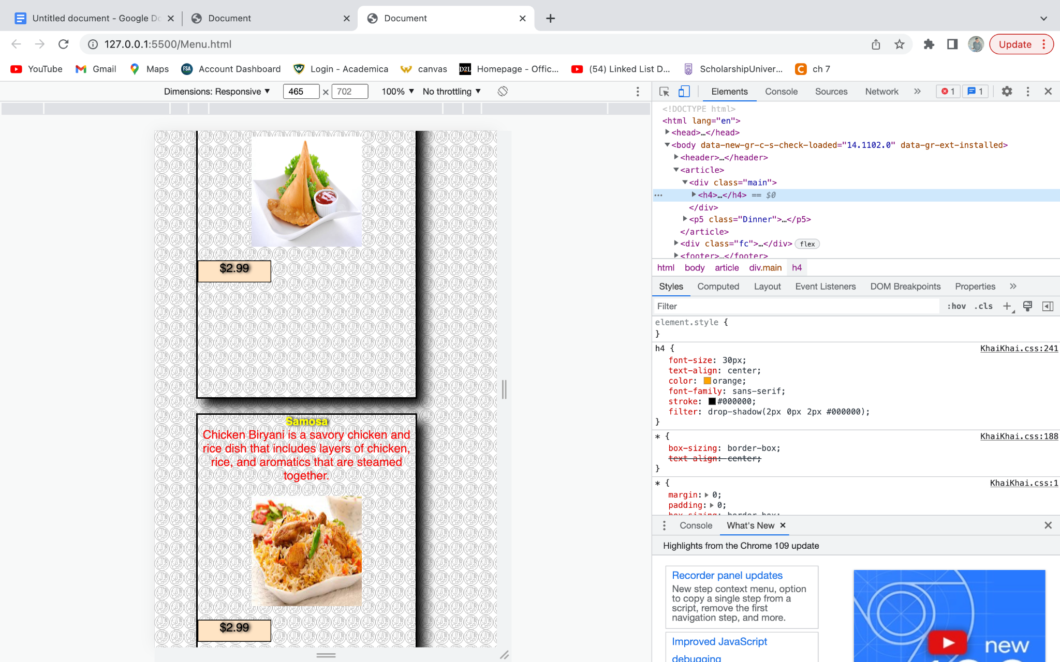

Some more ss of responsive design:

